**Haiti Money Remittance Location Analysis**

# **Introduction**

## **Background**

The **Republic of Haiti** is a country located on the island of Hispaniola in the Greater Antilles archipelago of the Caribbean Sea, to the east of Cuba and Jamaica and south of The Bahamas and the Turks and Caicos Islands. It occupies the western three-eighths of the island which it shares with the Dominican Republic. Haiti is 27,750 square kilometers (10,714 sq mi) in size, the third largest country in the Caribbean by area, and has an estimated population of 11.4 million, making it the most populous country in the Caribbean.

Historically poor and politically unstable, Haiti has the lowest Human Development Index in the Americas. Since the turn of the 21st century, the country has endured a *coup d'état,* which prompted a U.N. intervention, as well as a deadly earthquake that killed over 250,000.

Administratively, Haiti is divided into ten departments. The departments are listed below, with the departmental capital cities in parentheses.

1. Nord-Ouest (Port-de-Paix)
2. Nord (Cap-Haïtien)
3. Nord-Est (Fort-Liberté)
4. Artibonite (Gonaïves)
5. Centre (Hinche)
6. Ouest (Port-au-Prince)
7. Grand'Anse (Jérémie)
8. Nippes (Miragoâne)
9. Sud (Les Cayes)
10. Sud-Est (Jacmel)

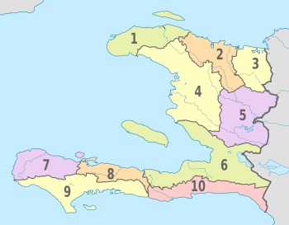

*The CIA World Factbook* also states that **"remittances are the primary source of foreign exchange, equaling one-fifth (20%) of GDP and representing more than five times the earnings from exports in 2012".**The World Bank estimates that over 80% of college graduates from Haiti were living abroad in 2004.

## **Problem**

As mentioned in the Background section Money Remittance is one of the main sources of income for Haiti. Based on this fact, it’s important to identify areas of opportunity to open Money Remittance locations in strategic areas that can comply with the demand for this type of service.

# **Data**

Based on the problem described several data source will be used for this project:

* Data of current locations obtained from one of the remittance company providers (private source) which will be used to understand which areas already have money remittance locations nearby.
* Foursquare API to obtain information on venues for the different Haiti departments for the analysis of possible locations opportunities.
* Wikipedia to obtain data of population per city and department which will help to analyze areas of opportunity.
* Google maps to obtain precise latitude and longitude coordinates.

# **Methodology**

For a list of all cities and its population I used Wikipedia and we obtain below table (sample):

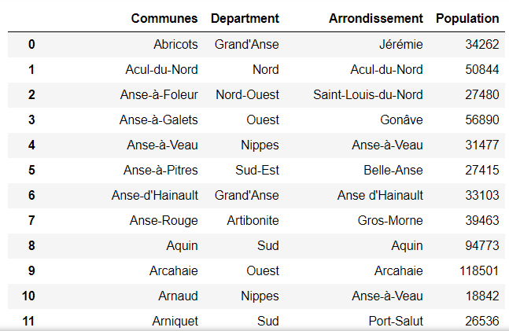

Which contains 140 entries. Still, as this project is focus on Department and to have a better understanding of the population, we removed “Communes” column, renamed “Arrondissement” column to be “City”, grouped the information by Department and sorted the data in descending order.

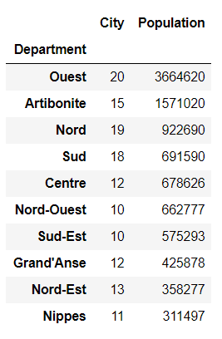

We can see the population is concentrated in Ouest Department.

Using Google maps to obtain coordinates for each Department and merged the data in one single dataframe:

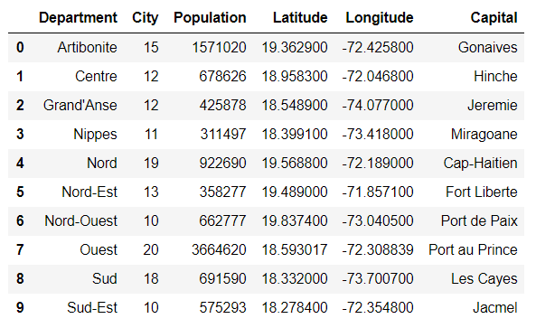

I used Folium Choropleth to create a map to visualize Haiti population by Department:

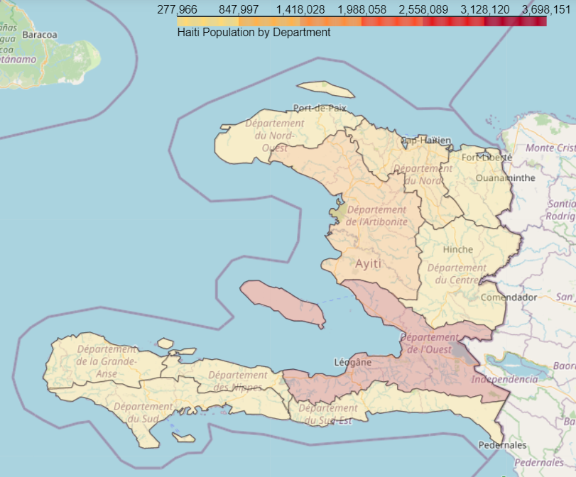

Below image give us an understanding of concentrated population on city level.

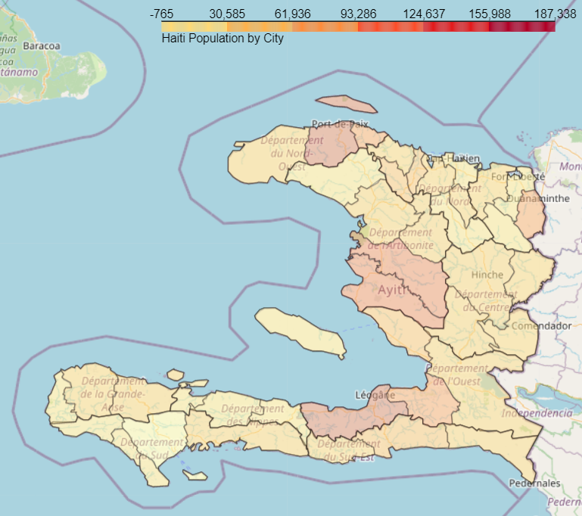

## **Remittance Data Analysis**

Data obtained from private resource where we can see location name, address, coordinates and general activity status. The data is for 1193 locations.

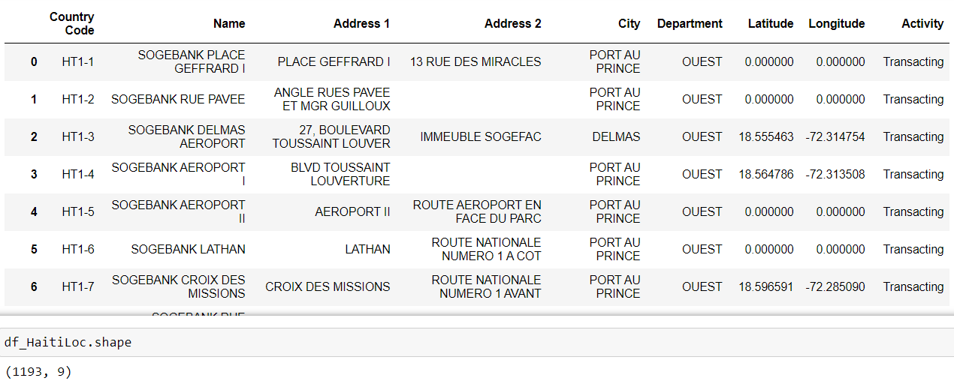

I grouped the data by Departments to have a better understanding of location distribution:

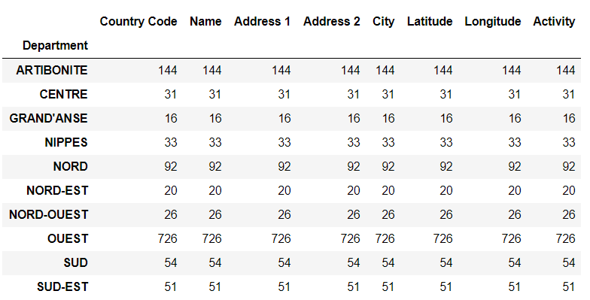

I used **folium** to visualize locations in Haiti in a map. I used color coding to easily identify locations with activity (green) and without activity (red).

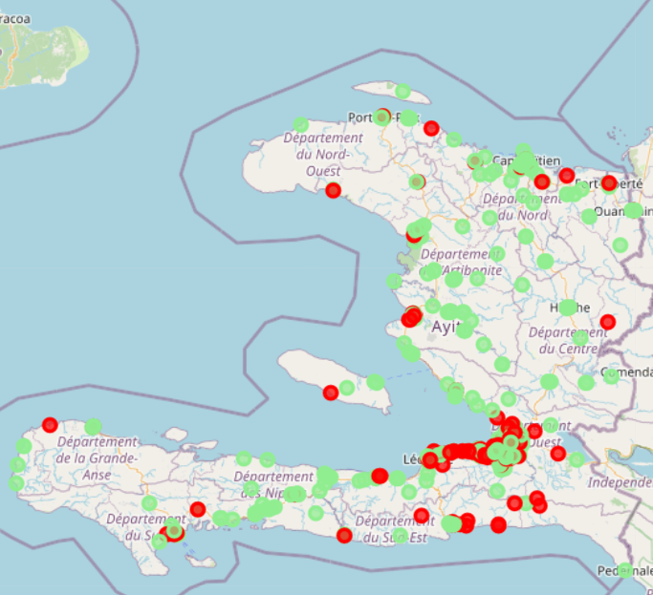

I used Foursquare API to explore nearby venues for whole Haiti. It’s atypical to do such a big search, but wanted a general view to provide to the stakeholders. That is why I used the radius of 150Km for the obtained coordinates for Haiti.

Below is a sample of list of venues obtained:

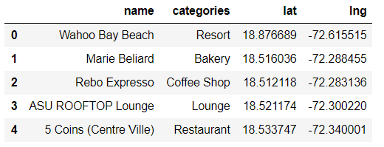

A total of 80 venues were returned with 42 unique categories.

I created map to show venues obtained in addition to locations and population by city, as it is easier to start visualizing gaps.

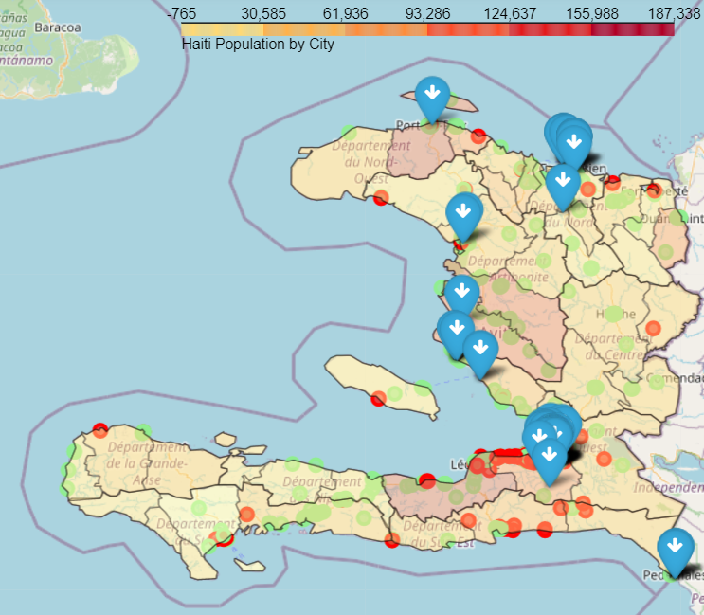

In order to create Venues clusters, I used the Elbow method to find the best K to utilize for K-means algorithm.

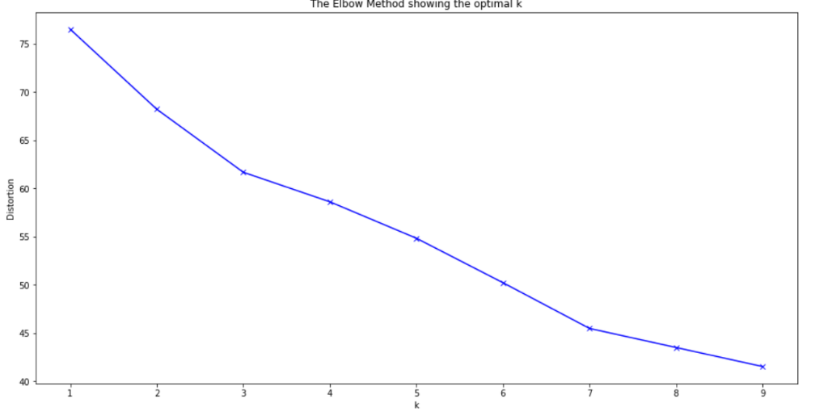

Unfortunately, the result is not 100% decisive, so I decided to use the value 4. And after running K-means algorithm, I merged the data to Venue table.

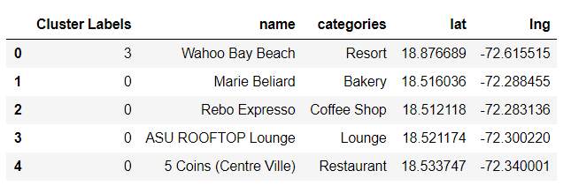

I created a DataFrame and used a bar plot for each cluster to better understand which categories were included and rename the clusters accordingly.

**Cluster 0**

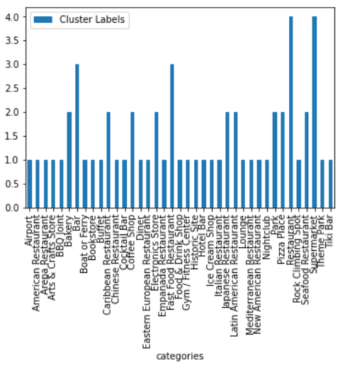

**Cluster 1**

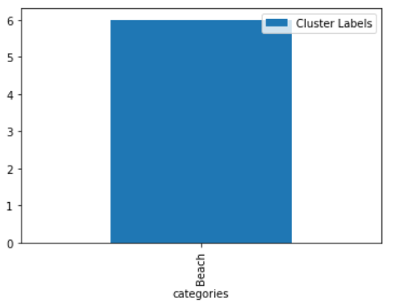

**Cluster 2**

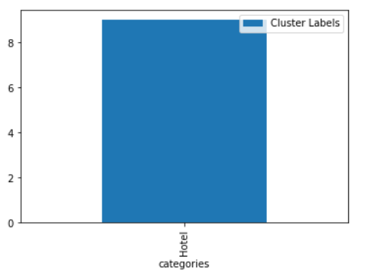

**Cluster 3**

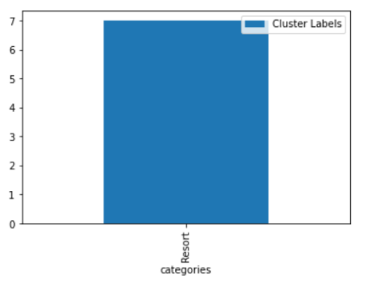

After reviewing each cluster, I updated the table with names for each cluster and obtained below table.

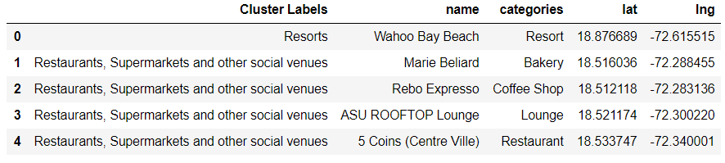

And updated map to show locations (with activity=green / without activity=grey) and venues in clusters.

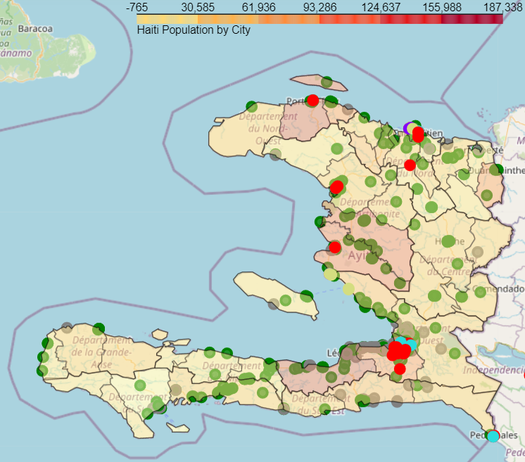

We will review the venues at each department in the following section. The same steps were taken for each Department:

1. Create DataFrame for corresponding Department by locating the name of the Department in Haiti Location DataFrame.
2. Setting latitude and longitude for each Department (I decided to use coordinates obtained from Google maps).
3. Obtain venues using Foursquare API (radius varies by Department to obtain better results) and create a DataFrame based on the results.
4. Create map that includes venues, locations and population.
5. Use Elbow method to help identify the best K for clusters creation.
6. Use K-means algorithm to create clusters.
7. Add clusters to Department DataFrame.
8. Create a DataFrame and bar plot for each cluster to identify categories grouped in each cluster.
9. Rename each cluster.
10. Update cluster label in Department DataFrame.
11. Create map that includes venues, locations, population and clusters.

### **Ouest Department**

We have 61% of the locations in Ouest which is expected as this Department is where the capital Port-au-Prince is located.

1. Create DataFrame for corresponding Department by locating the name of the Department in Haiti Location DataFrame.

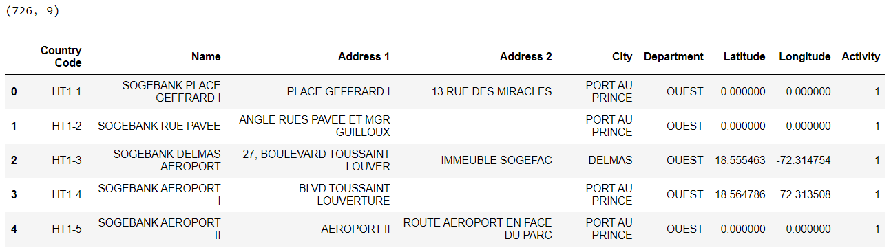

1. Setting latitude and longitude for each Department (I decided to use coordinates obtained from Google maps).

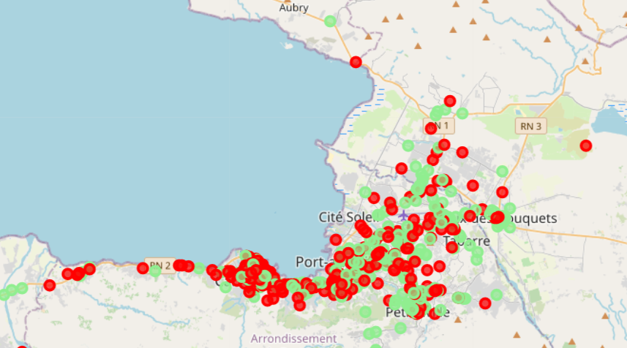

1. Obtain venues using Foursquare API (radius varies by Department to obtain better results) and create a DataFrame based on the results.

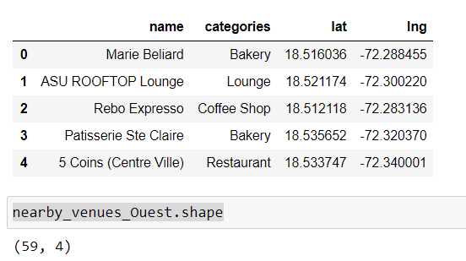

1. Create map that includes venues, locations and population.

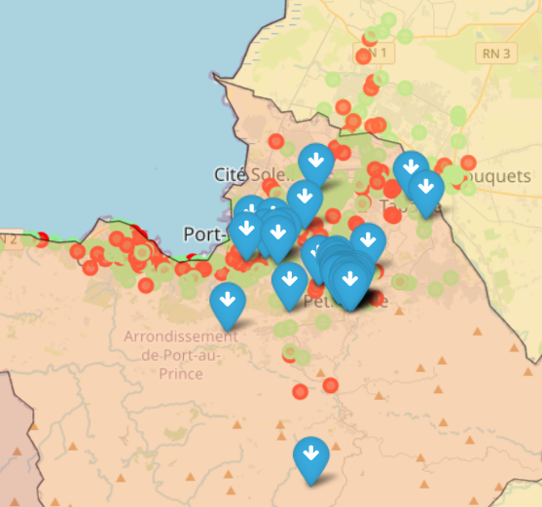

1. Use Elbow method to help identify the best K for clusters creation.

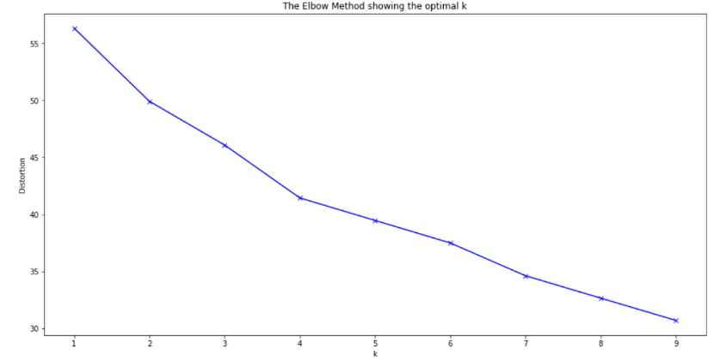

1. Use K-means algorithm to create clusters.
2. Add clusters to Department DataFrame.

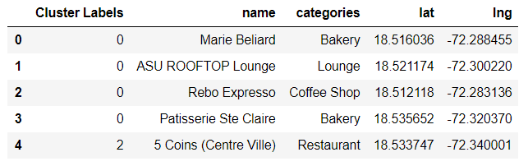

1. Create a DataFrame and bar plot for each cluster to identify categories grouped in each cluster.

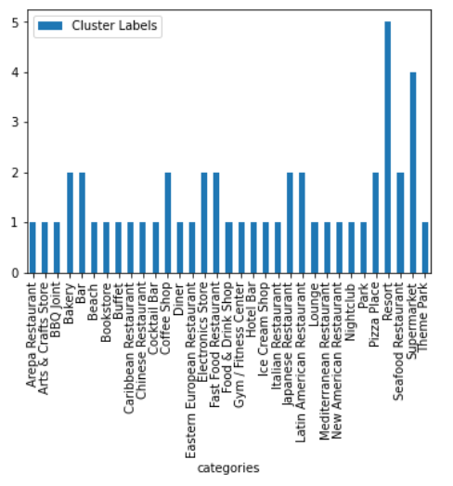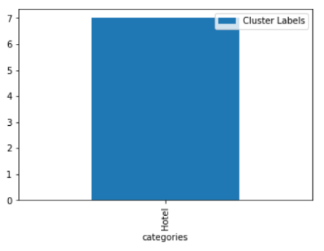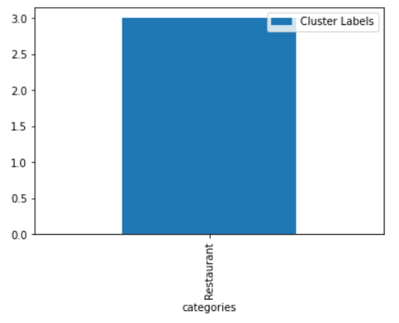

1. Rename each cluster.
2. Update cluster label in Department DataFrame.

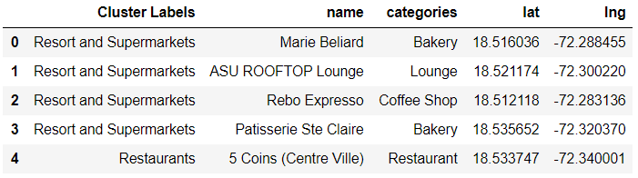

1. Create map that includes venues, locations, population and clusters.

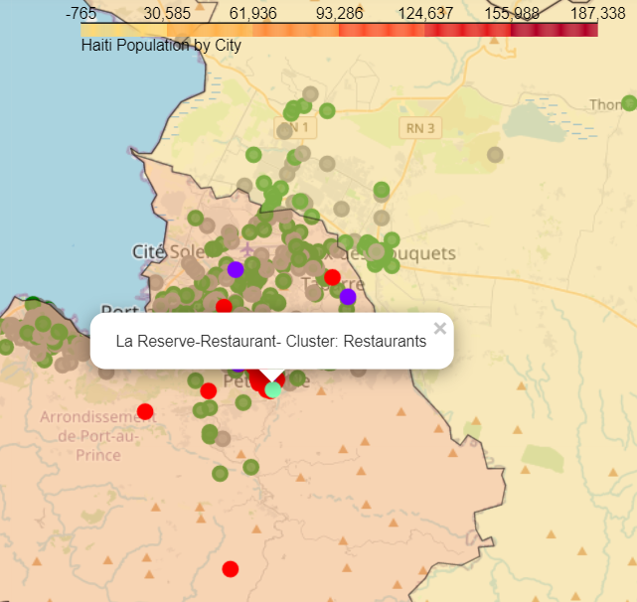

### **Artibonite Department**

1. Create DataFrame for corresponding Department by locating the name of the Department in Haiti Location DataFrame.

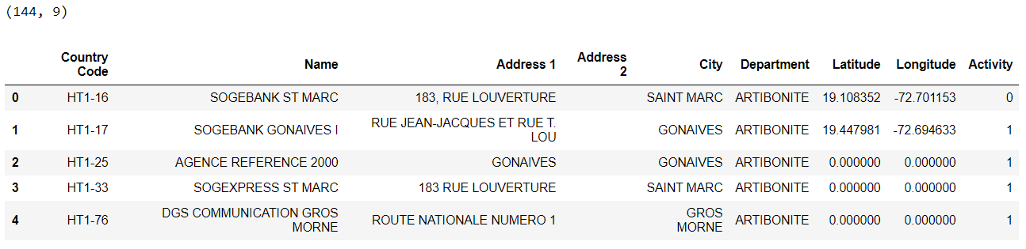

1. Setting latitude and longitude for each Department (I decided to use coordinates obtained from Google maps).

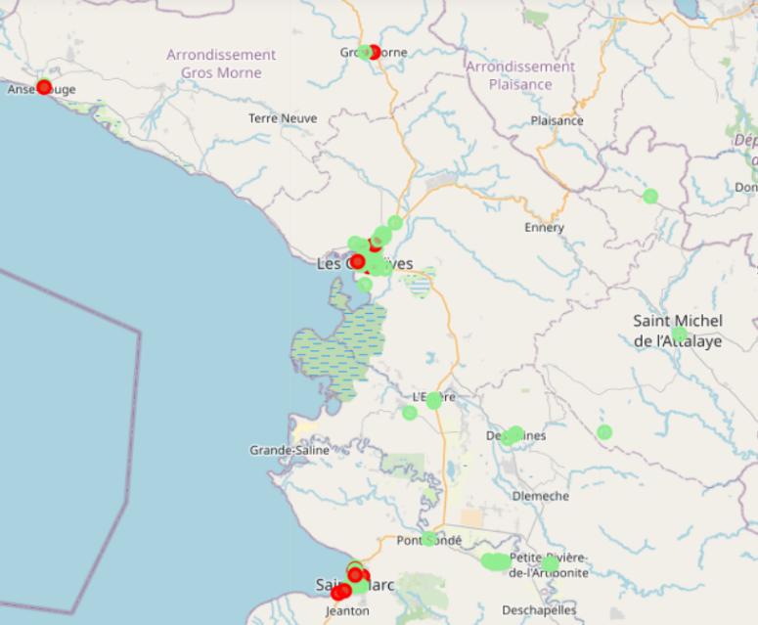

1. Obtain venues using Foursquare API (radius varies by Department to obtain better results) and create a DataFrame based on the results.

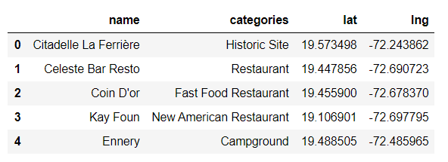

1. Create map that includes venues, locations and population.

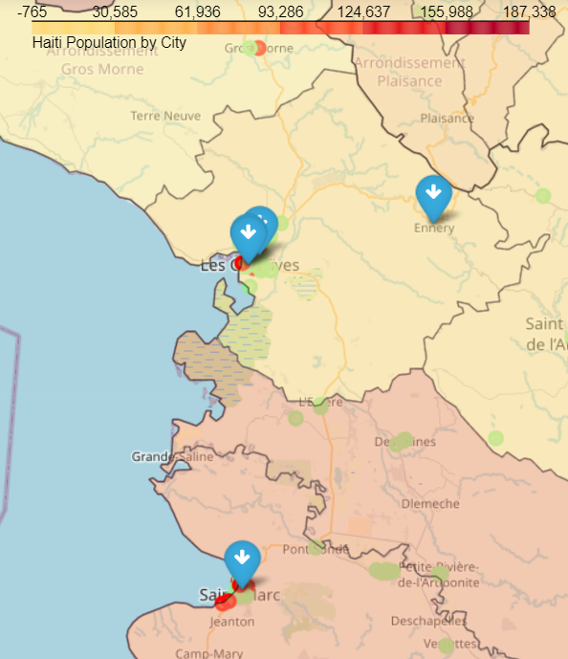

1. Use Elbow method to help identify the best K for clusters creation.

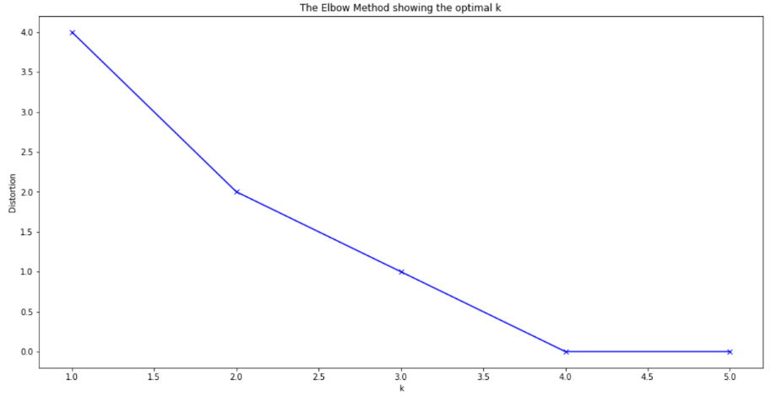

1. Use K-means algorithm to create clusters.
2. Add clusters to Department DataFrame.

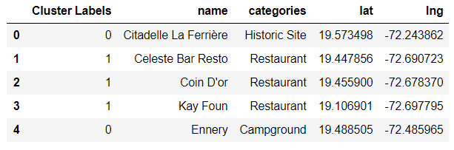

1. Create a DataFrame and bar plot for each cluster to identify categories grouped in each cluster.

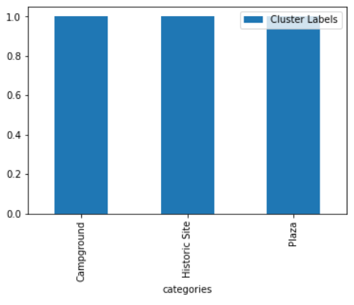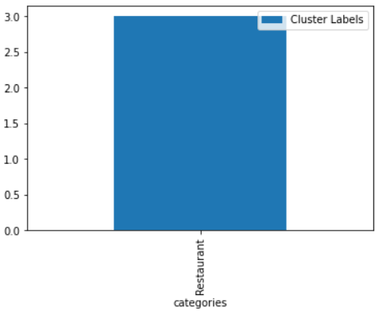

1. Rename each cluster.
2. Update cluster label in Department DataFrame.

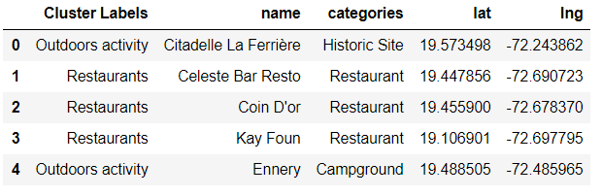

1. Create map that includes venues, locations, population and clusters.

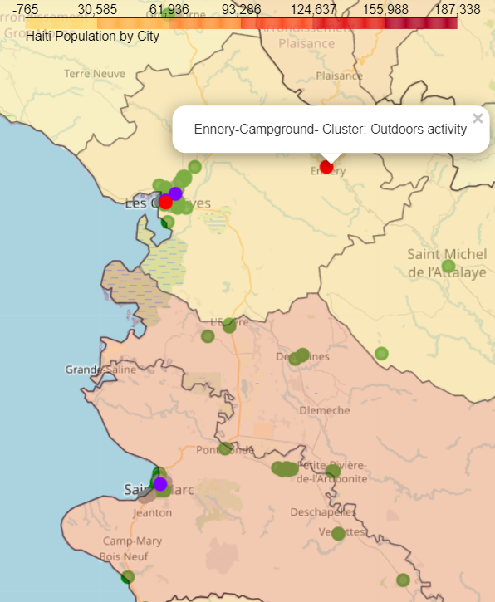

### **Centre Department**

1. Create DataFrame for corresponding Department by locating the name of the Department in Haiti Location DataFrame.

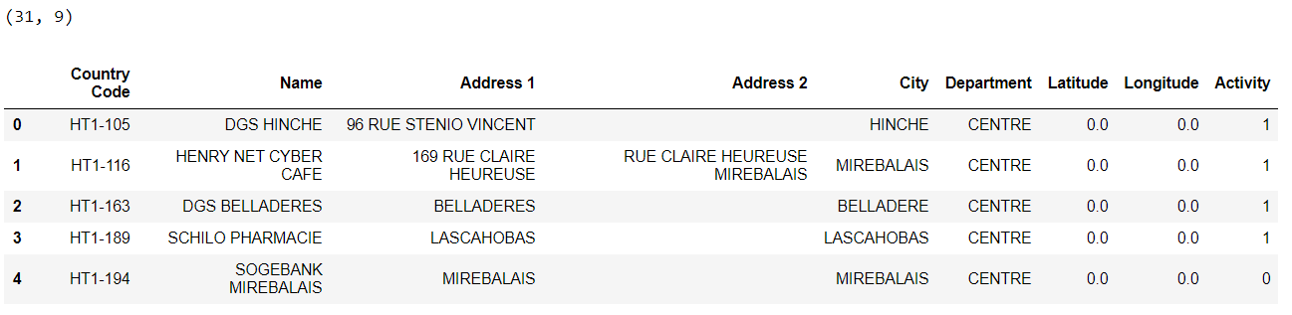

1. Setting latitude and longitude for each Department (I decided to use coordinates obtained from Google maps).

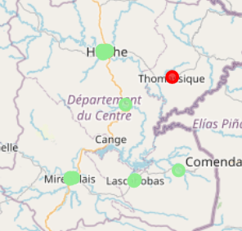

1. Obtain venues using Foursquare API (radius varies by Department to obtain better results) and create a DataFrame based on the results.

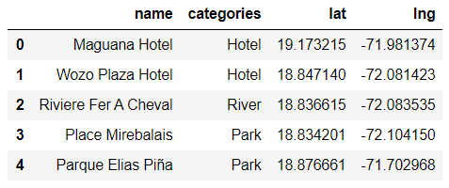

1. Create map that includes venues, locations and population.

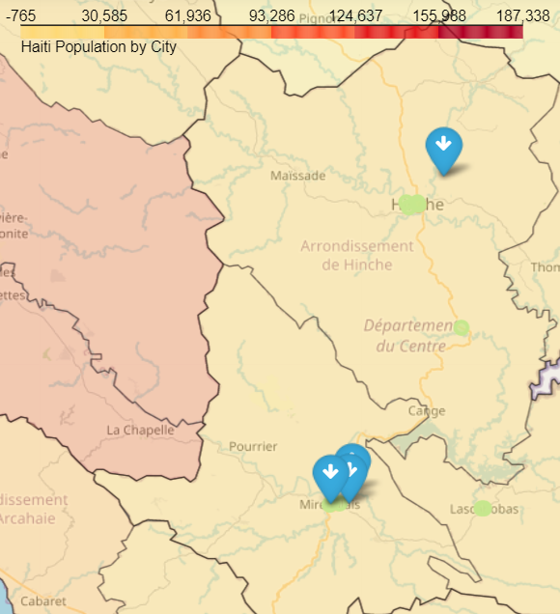

1. Use Elbow method to help identify the best K for clusters creation.

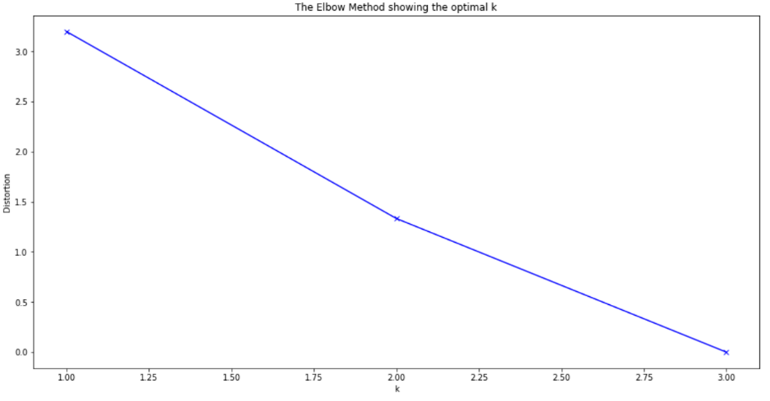

1. Use K-means algorithm to create clusters.
2. Add clusters to Department DataFrame.

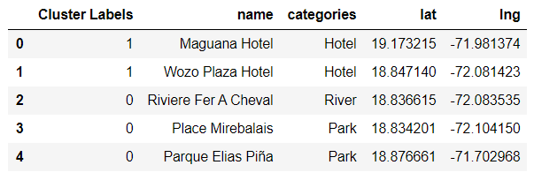

1. Create a DataFrame and bar plot for each cluster to identify categories grouped in each cluster.
2. Rename each cluster.

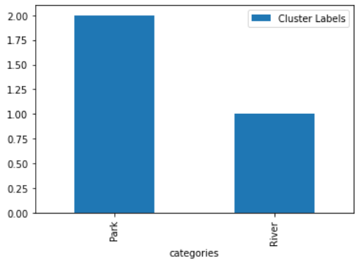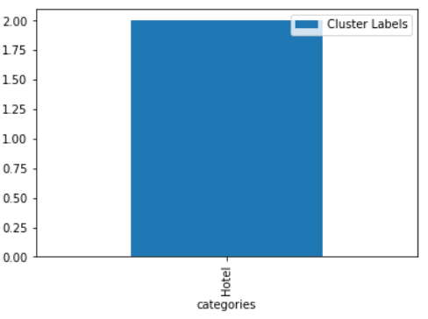

1. Update cluster label in Department DataFrame.

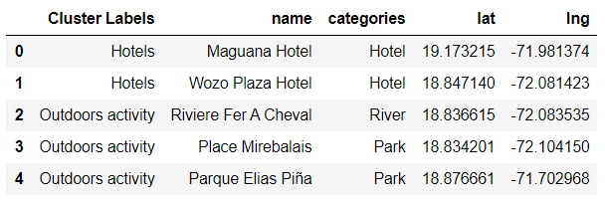

1. Create map that includes venues, locations, population and clusters.

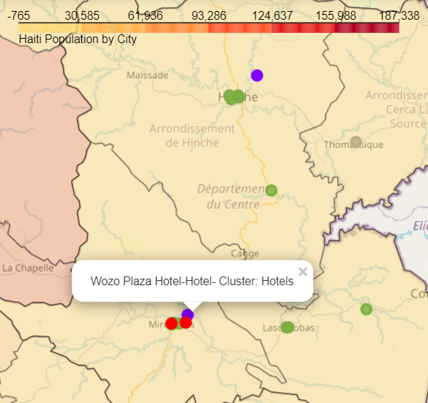

### **Grand’Anse Department**

1. Create DataFrame for corresponding Department by locating the name of the Department in Haiti Location DataFrame.

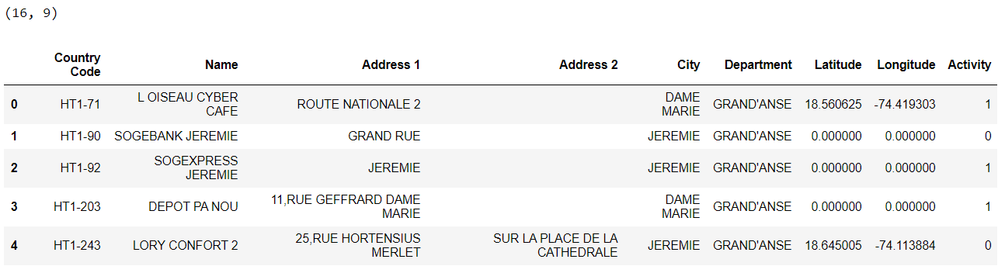

1. Setting latitude and longitude for each Department (I decided to use coordinates obtained from Google maps).

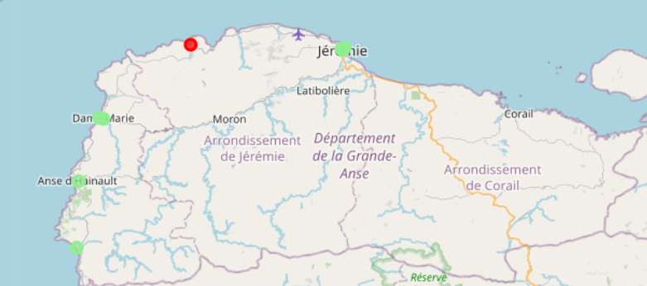

1. Obtain venues using Foursquare API (radius varies by Department to obtain better results) and create a DataFrame based on the results.

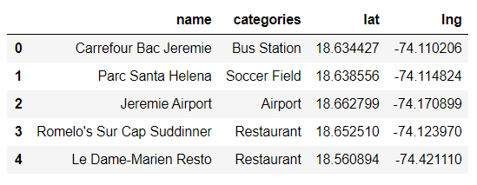

1. Create map that includes venues, locations and population.

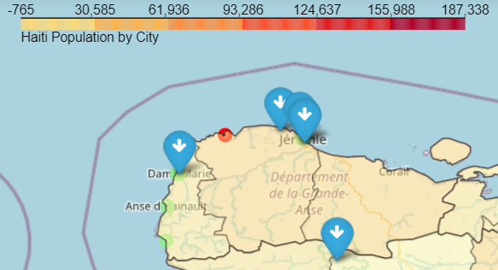

1. Use Elbow method to help identify the best K for clusters creation.

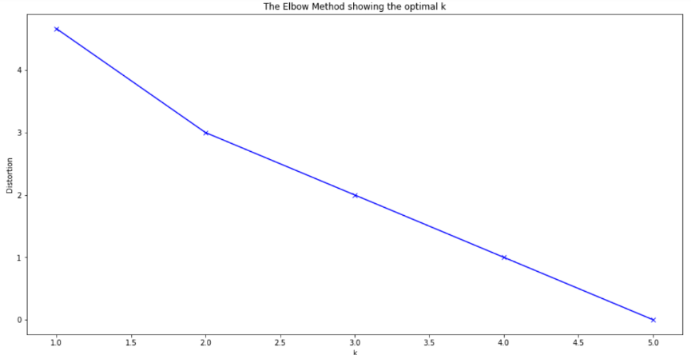

1. Use K-means algorithm to create clusters.
2. Add clusters to Department DataFrame.

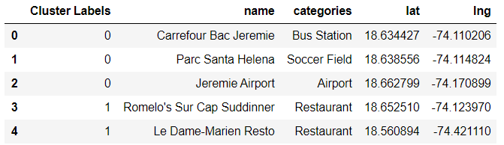

1. Create a DataFrame and bar plot for each cluster to identify categories grouped in each cluster.

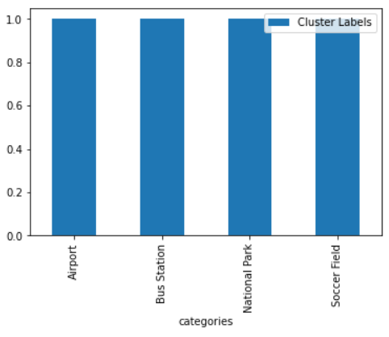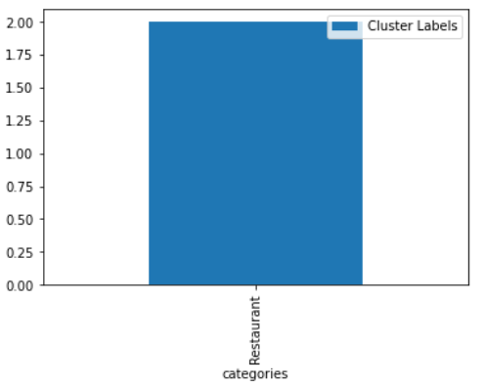

1. Rename each cluster.
2. Update cluster label in Department DataFrame.

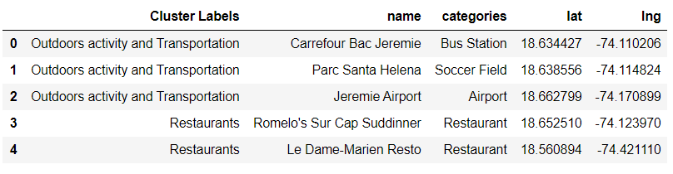

1. Create map that includes venues, locations, population and clusters.

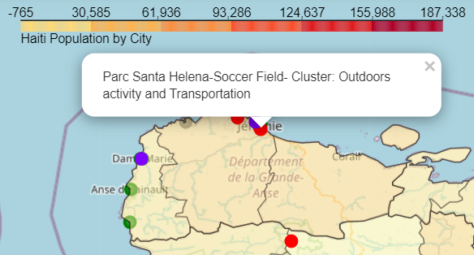

### **Nippes Department**

1. Create DataFrame for corresponding Department by locating the name of the Department in Haiti Location DataFrame.

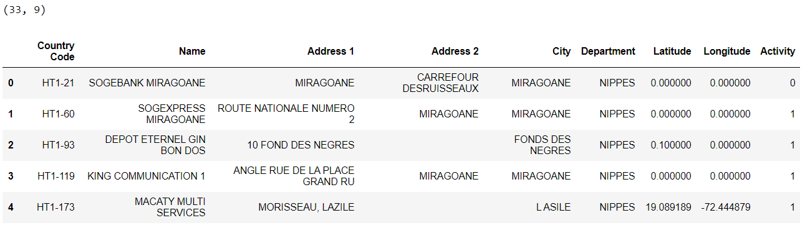

1. Setting latitude and longitude for each Department (I decided to use coordinates obtained from Google maps).

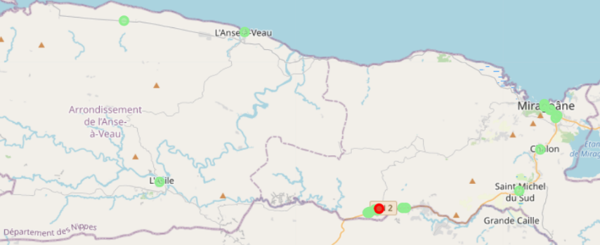

1. Obtain venues using Foursquare API (radius varies by Department to obtain better results) and create a DataFrame based on the results.

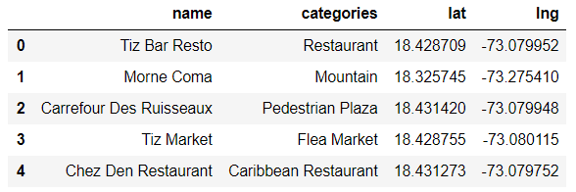

1. Create map that includes venues, locations and population.

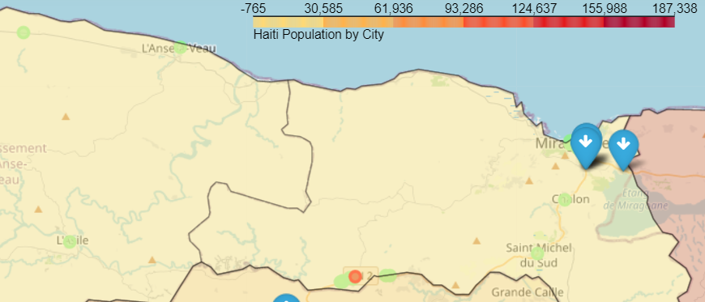

1. Use Elbow method to help identify the best K for clusters creation.

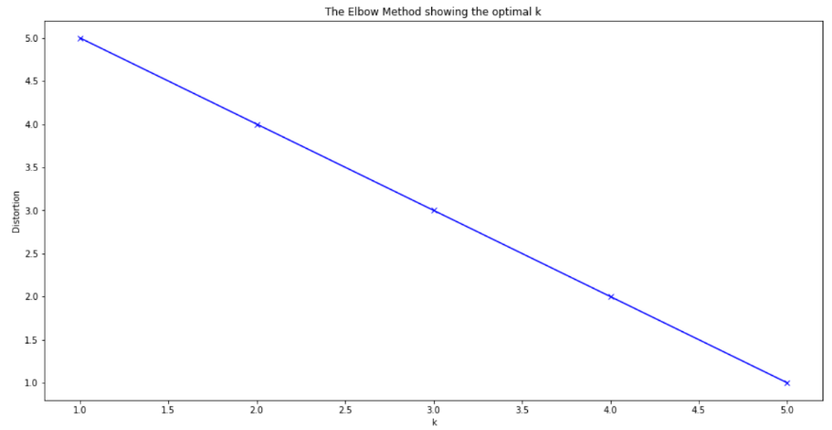

1. Use K-means algorithm to create clusters.
2. Add clusters to Department DataFrame.

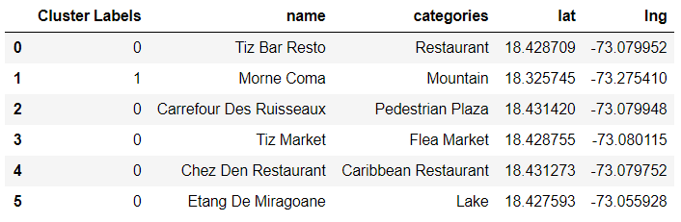

1. Create a DataFrame and bar plot for each cluster to identify categories grouped in each cluster.

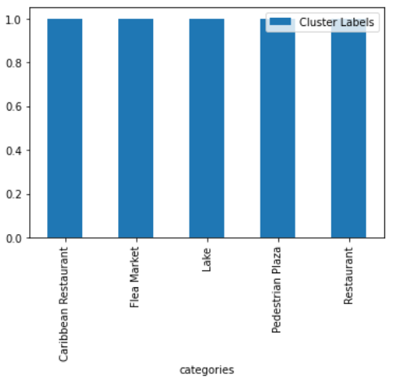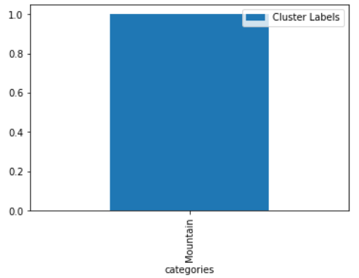

1. Rename each cluster.
2. Update cluster label in Department DataFrame.

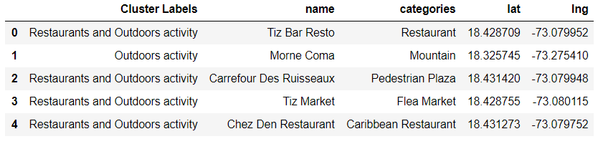

1. Create map that includes venues, locations, population and clusters.

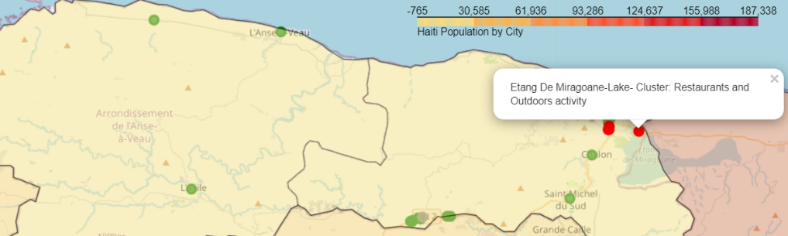

### **Nord Department**

1. Create DataFrame for corresponding Department by locating the name of the Department in Haiti Location DataFrame.

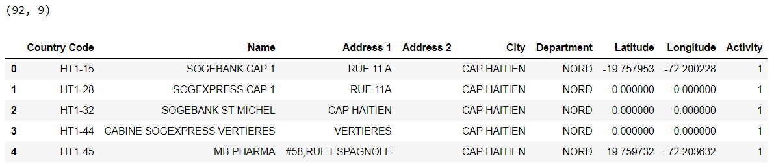

1. Setting latitude and longitude for each Department (I decided to use coordinates obtained from Google maps).

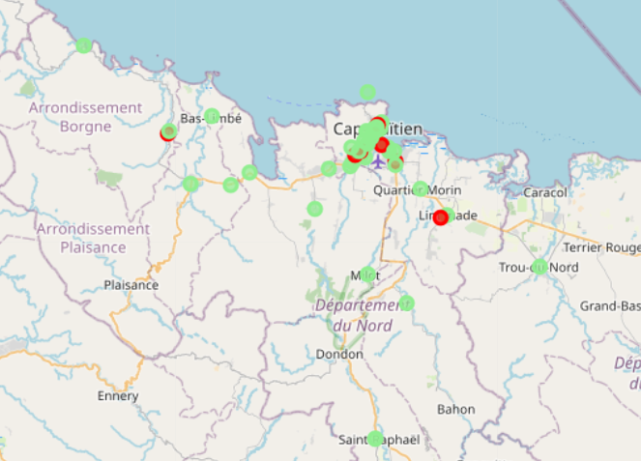

1. Obtain venues using Foursquare API (radius varies by Department to obtain better results) and create a DataFrame based on the results.

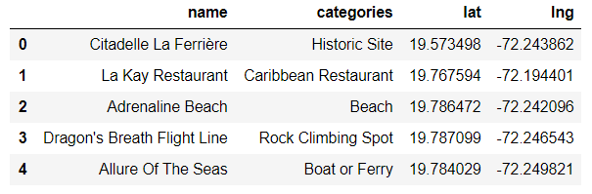

1. Create map that includes venues, locations and population.

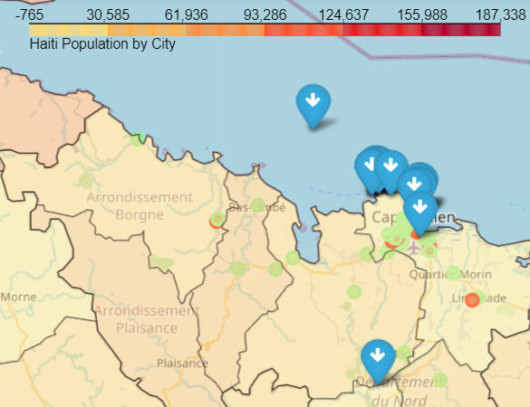

1. Use Elbow method to help identify the best K for clusters creation.

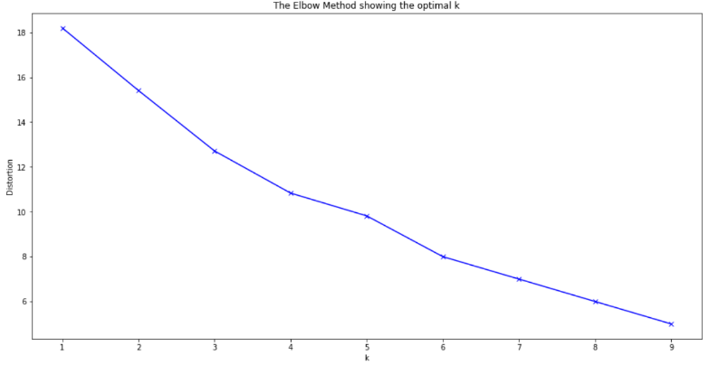

1. Use K-means algorithm to create clusters.
2. Add clusters to Department DataFrame.

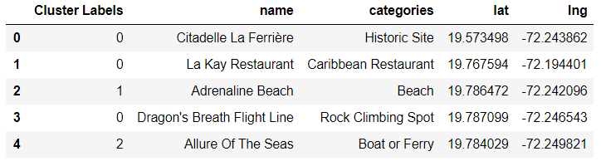

1. Create a DataFrame and bar plot for each cluster to identify categories grouped in each cluster.

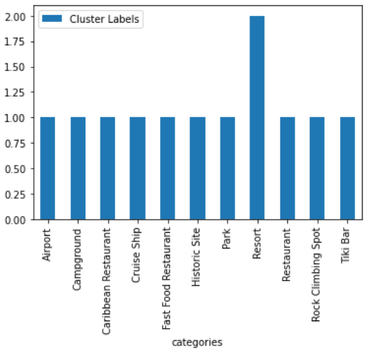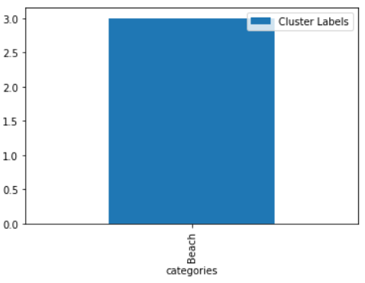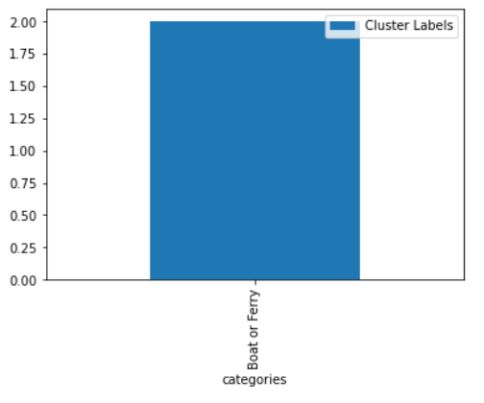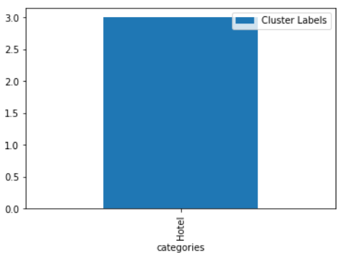

1. Rename each cluster.
2. Update cluster label in Department DataFrame.

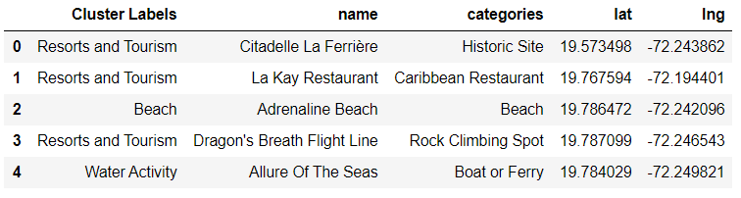

1. Create map that includes venues, locations, population and clusters.

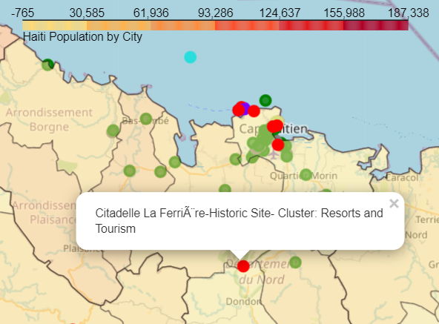

### **Nord-Est Department**

1. Create DataFrame for corresponding Department by locating the name of the Department in Haiti Location DataFrame.

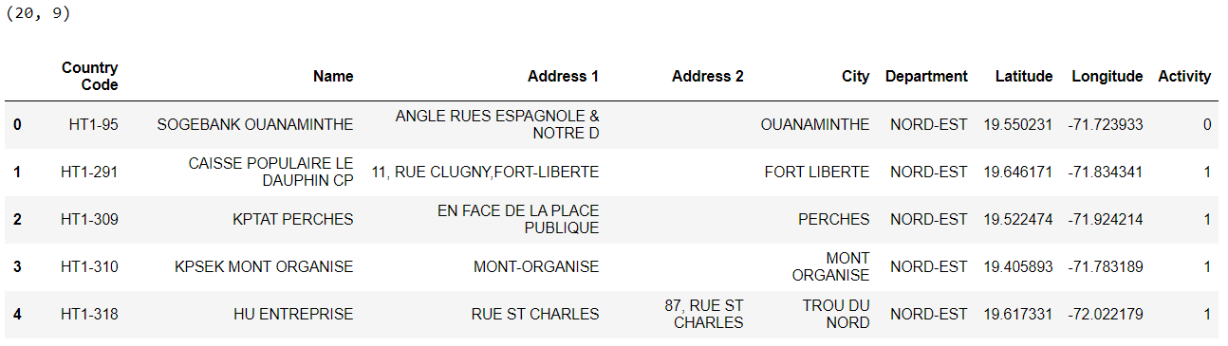

1. Setting latitude and longitude for each Department (I decided to use coordinates obtained from Google maps).

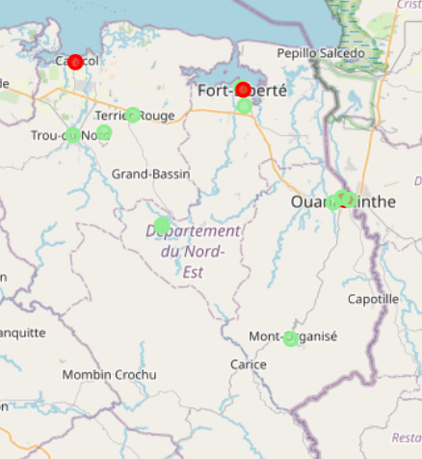

1. Obtain venues using Foursquare API (radius varies by Department to obtain better results) and create a DataFrame based on the results.

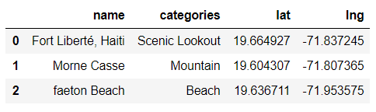

1. Create map that includes venues, locations and population.

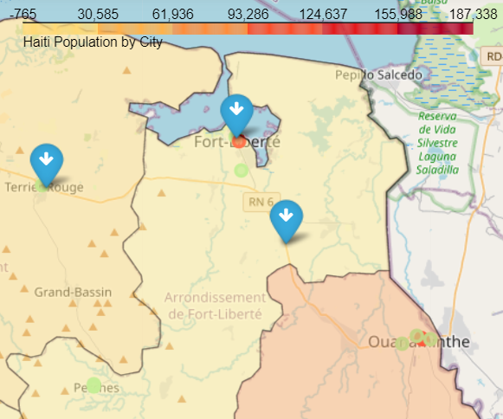

1. Use Elbow method to help identify the best K for clusters creation.

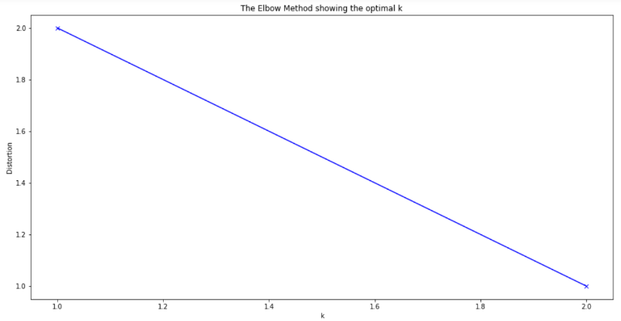

1. Use K-means algorithm to create clusters.
2. Add clusters to Department DataFrame.

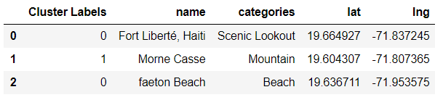

1. Create a DataFrame and bar plot for each cluster to identify categories grouped in each cluster.

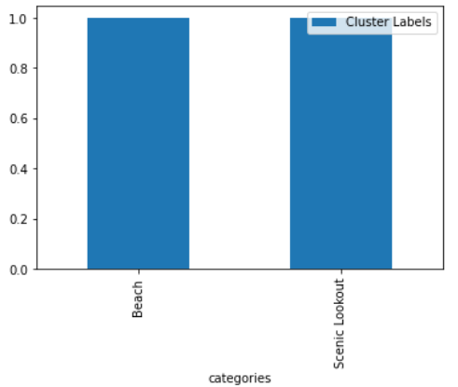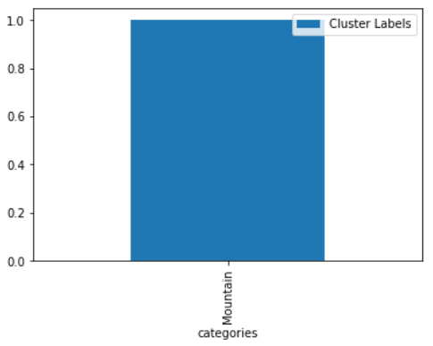

1. Rename each cluster.
2. Update cluster label in Department DataFrame.

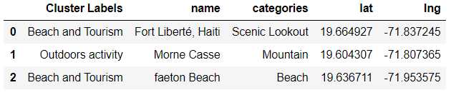

1. Create map that includes venues, locations, population and clusters.

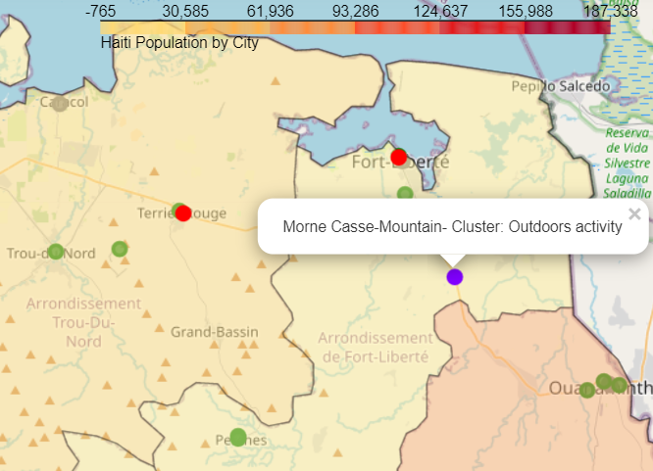

### **Nord-Ouest Department**

1. Create DataFrame for corresponding Department by locating the name of the Department in Haiti Location DataFrame.

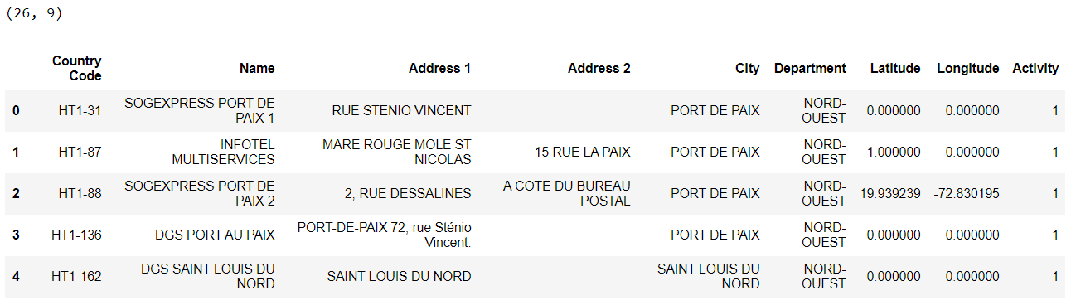

1. Setting latitude and longitude for each Department (I decided to use coordinates obtained from Google maps).

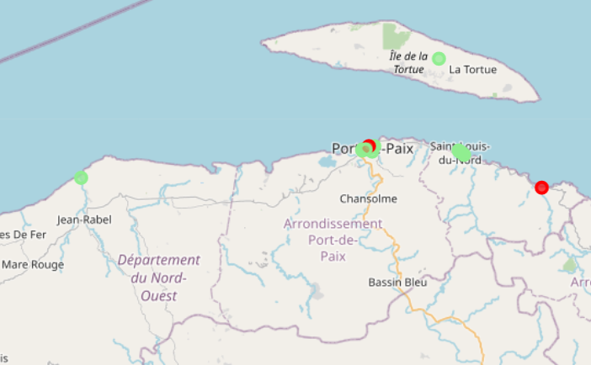

1. Obtain venues using Foursquare API (radius varies by Department to obtain better results) and create a DataFrame based on the results.

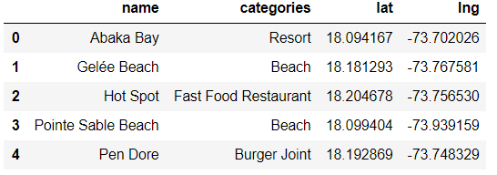

1. Create map that includes venues, locations and population.

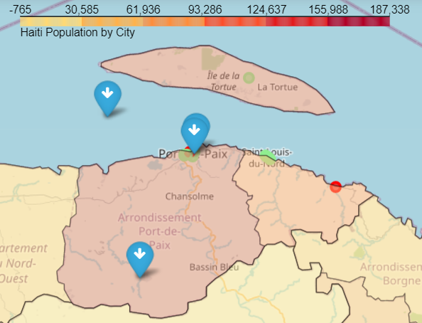

1. Use Elbow method to help identify the best K for clusters creation.

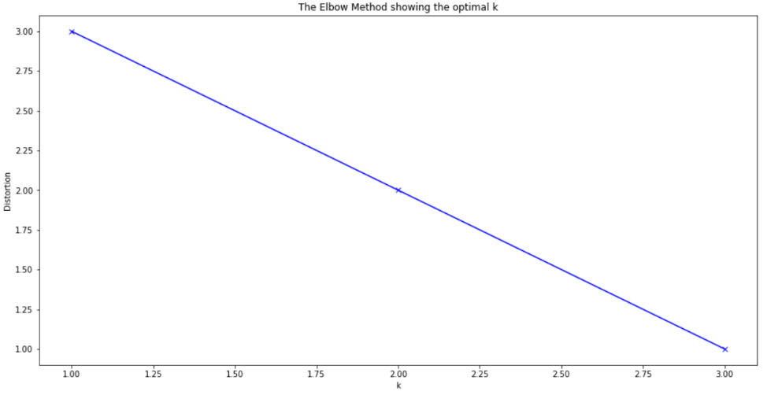

1. Use K-means algorithm to create clusters.
2. Add clusters to Department DataFrame.

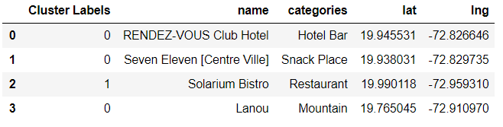

1. Create a DataFrame and bar plot for each cluster to identify categories grouped in each cluster.

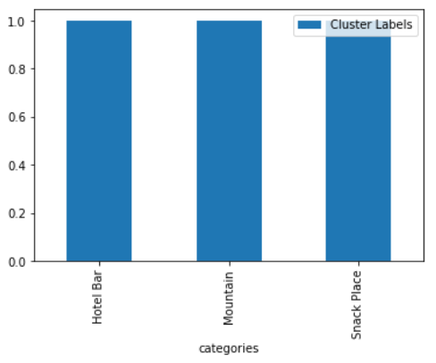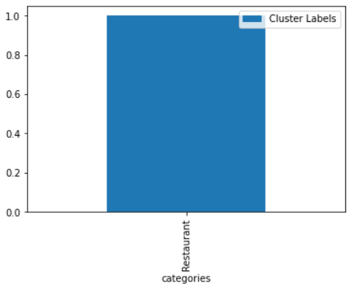

1. Rename each cluster.
2. Update cluster label in Department DataFrame.

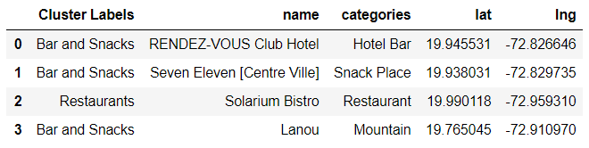

1. Create map that includes venues, locations, population and clusters.

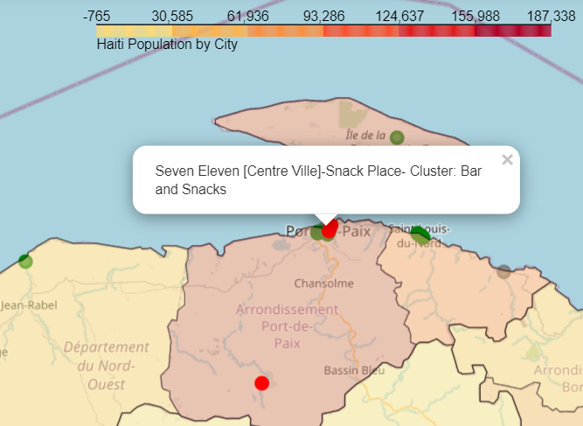

### **Sud Department**

1. Create DataFrame for corresponding Department by locating the name of the Department in Haiti Location DataFrame.

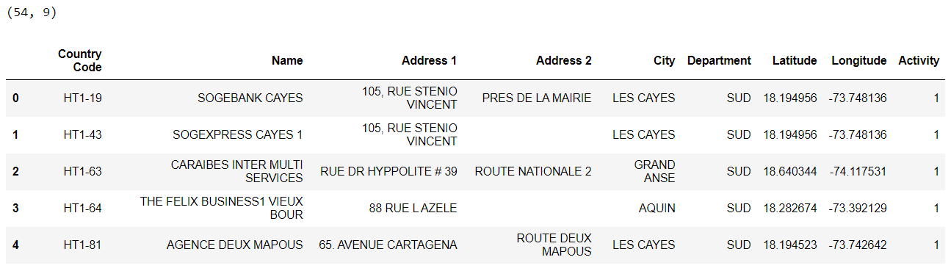

1. Setting latitude and longitude for each Department (I decided to use coordinates obtained from Google maps).

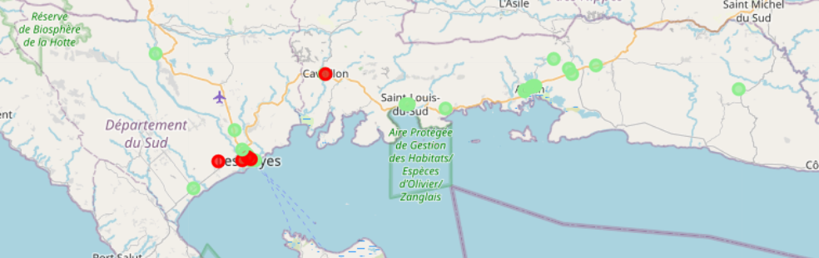

1. Obtain venues using Foursquare API (radius varies by Department to obtain better results) and create a DataFrame based on the results.

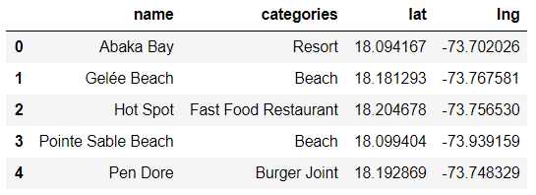

1. Create map that includes venues, locations and population.

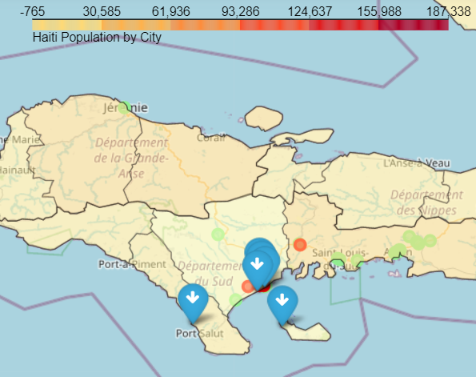

1. Use Elbow method to help identify the best K for clusters creation.

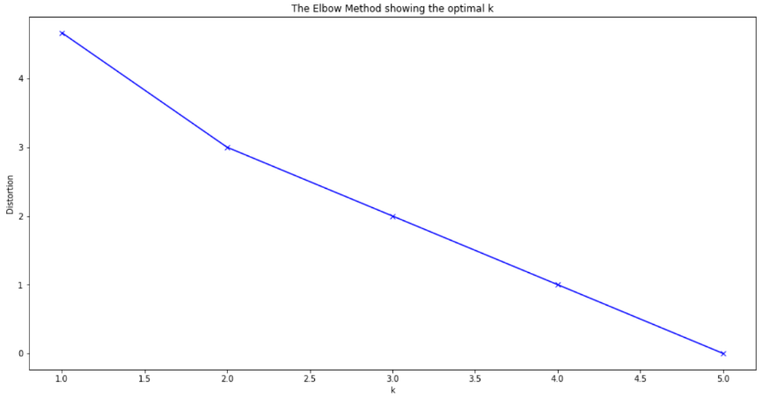

1. Use K-means algorithm to create clusters.
2. Add clusters to Department DataFrame.

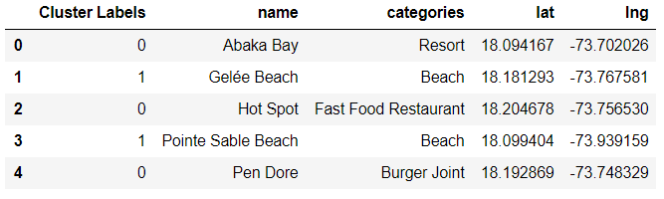

1. Create a DataFrame and bar plot for each cluster to identify categories grouped in each cluster.

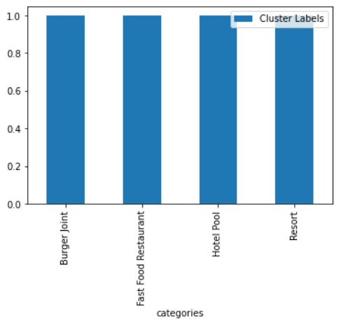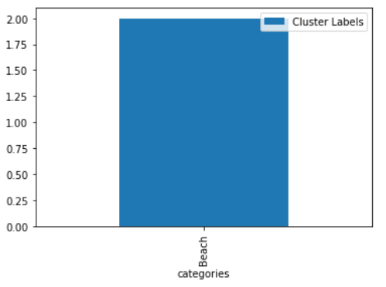

1. Rename each cluster.
2. Update cluster label in Department DataFrame.

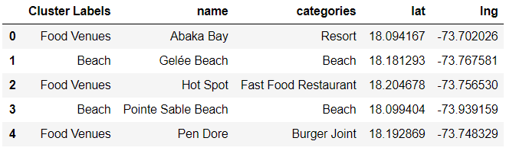

1. Create map that includes venues, locations, population and clusters.

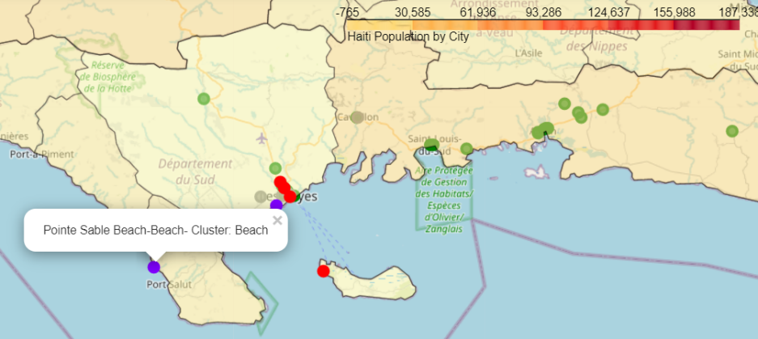

### **Sud-Est Department**

1. Create DataFrame for corresponding Department by locating the name of the Department in Haiti Location DataFrame.

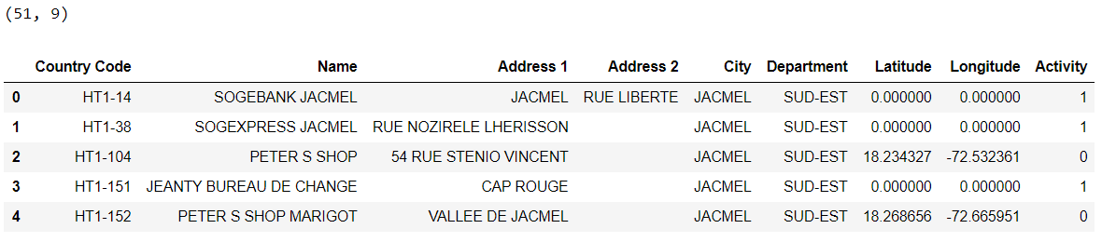

1. Setting latitude and longitude for each Department (I decided to use coordinates obtained from Google maps).

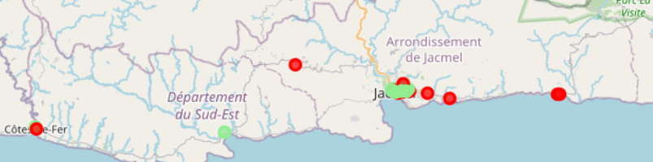

1. Obtain venues using Foursquare API (radius varies by Department to obtain better results) and create a DataFrame based on the results.

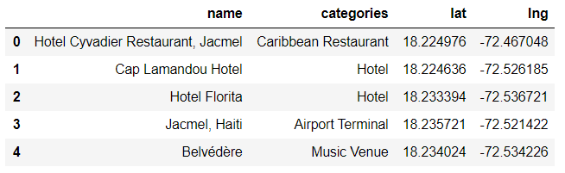

1. Create map that includes venues, locations and population.

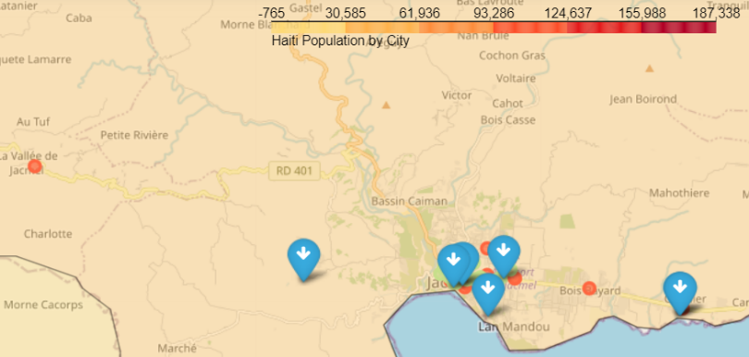

1. Use Elbow method to help identify the best K for clusters creation.

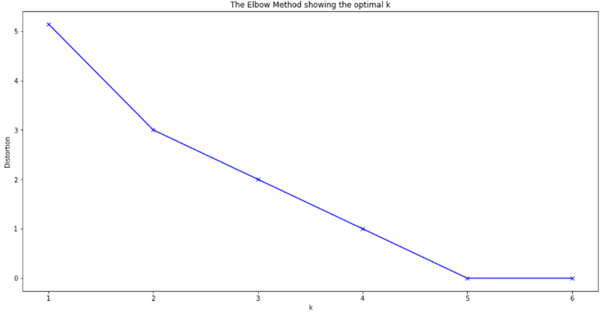

1. Use K-means algorithm to create clusters.
2. Add clusters to Department DataFrame.

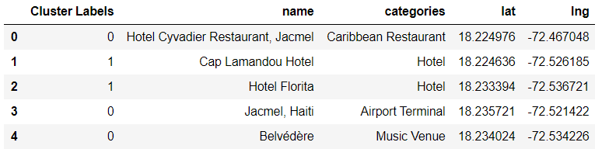

1. Create a DataFrame and bar plot for each cluster to identify categories grouped in each cluster.

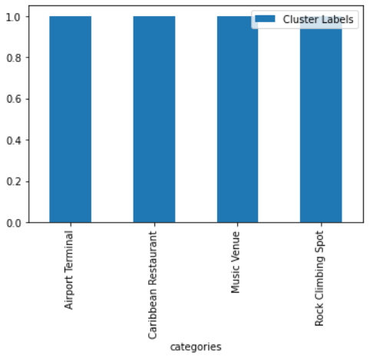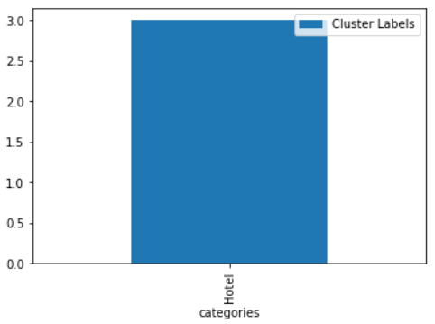

1. Rename each cluster.
2. Update cluster label in Department DataFrame.

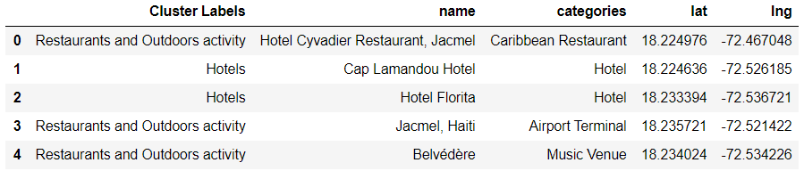

1. Create map that includes venues, locations, population and clusters.

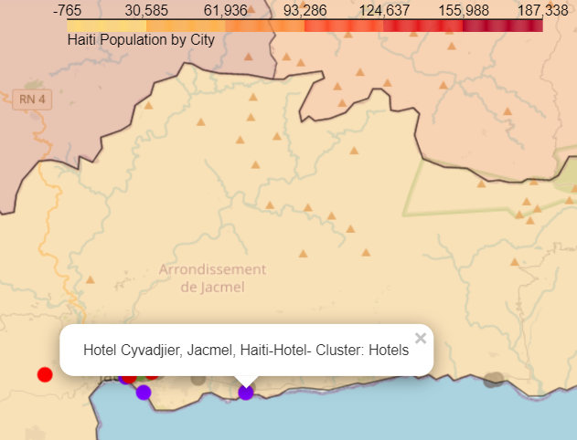

# **Results**

The final map for Haiti and for each Department provides visibility of possible gaps where Money Remittance locations could be a good opportunity for a Money Remittance enterprise and gain for Haitian community.

As additional points, the analysis provided other inputs for the enterprise to review, analyze and optimize their current locations distribution.

# **Discussion**

The original goal was to review Haiti as a whole, I went a little deeper by reviewing the data on Department level. Still, based on the results it’s clear that a deeper review is necessary either on city level or even better on commune level to obtain more accurate data.

There were also several data missing:

* Locations with No Value in Activity, for this project I made the assumption these locations were indeed transacting.
* 271 locations either didn’t have geo coordinates or the ones provided are incorrect (not Haiti). This caused the map results to be incomplete.

In addition, while reviewing the locations by Department it was clear that several coordinates were incorrect, as locations that should appear in one Department showed in a different Department in the map.

# **Conclusion**

There are several opportunities for the stakeholders on different areas:

* Data clean-up to ensure coordinates and addresses are accurate.
* Current locations very close to other locations which affects activity/productivity. They should review with local team to analyze the cases and better resource usage.
* Work with local team to review potential zones in which a location could be enabled to attract more customers or even a new category of customers.

# **References**

1. [Haiti - Wikipedia](https://en.wikipedia.org/wiki/Haiti)
2. [List of cities in Haiti - Wikipedia](https://en.wikipedia.org/wiki/List_of_cities_in_Haiti)
3. [Haiti - Google Maps](https://www.google.com/maps/place/Haiti/@19.034398,-74.2391432,8z/data=!3m1!4b1!4m5!3m4!1s0x8eb6c6f37fcbbb11:0xb51438b24c54f6d3!8m2!3d18.971187!4d-72.285215)
4. [Developer | Foursquare](https://developer.foursquare.com/developer/)